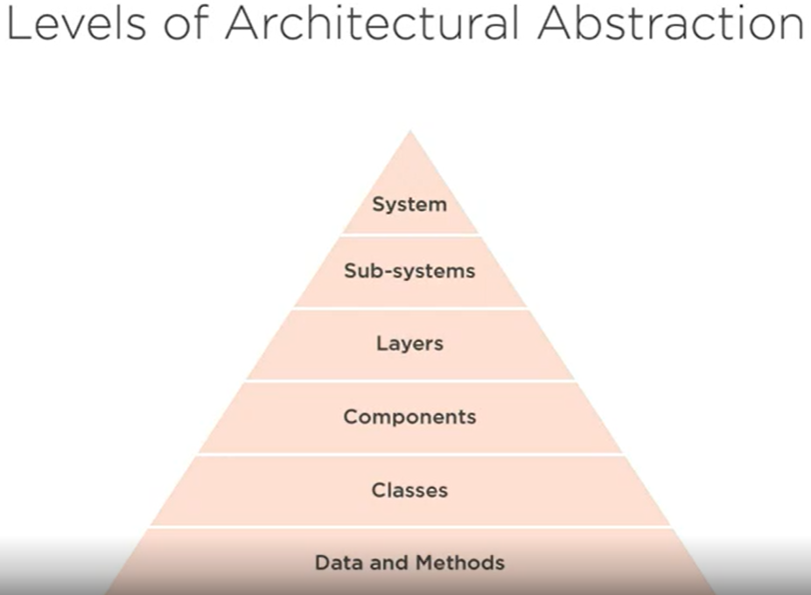
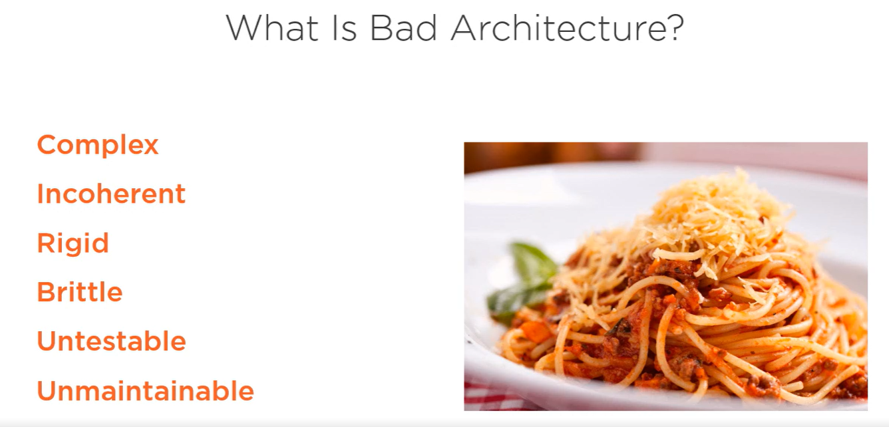
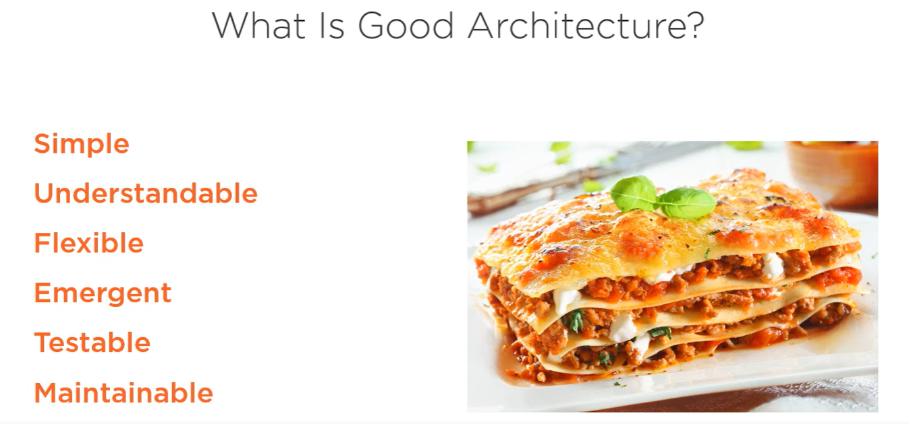
Clean architecture is a philosophy of architectural essentialism. It's about focusing on what is truly essential to the software's architecture versus what is just an implementation detail. By designing for the inhabitants, we mean the people that will be living within the architecture during the life of the project. This means the users of the system, the developers building the system, and the developers maintaining the system. By not designing for the architect, we mean that the architect should put aside his or her own desires, preferences, and wishes and only consider what is best for the inhabitants of the architecture with each decision that is made.
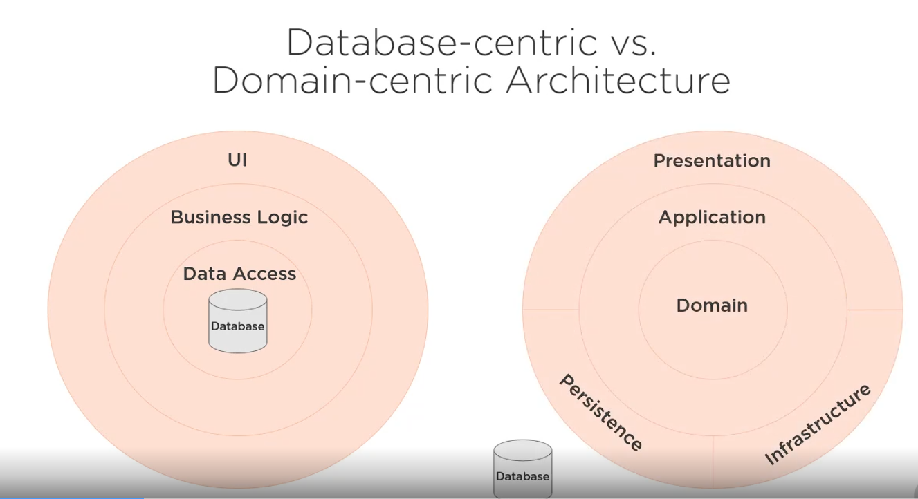
Types of Domain Centric Architecture:
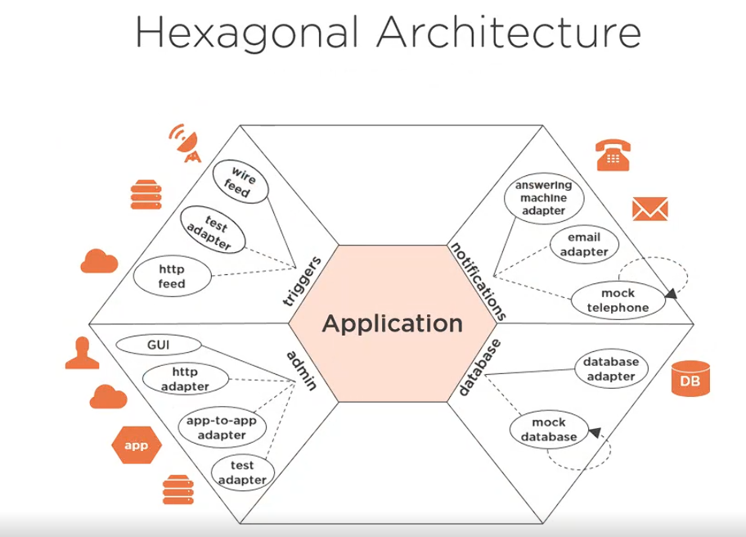
1. The Core Idea of Hexagonal Architecture
The main goal is:
Keep your business logic independent of frameworks, UI, databases, and external services.
Instead of your application depending directly on things like HTTP, databases, or email services, those concerns are pushed to the outside.
Think of the application as a hexagon:
- The center is your business logic
- The edges are well-defined interaction points (ports)
- The outside contains adapters that connect to real-world systems

2. The Center: Application
In the middle of the diagram you see:
Application
This is the core domain / business logic.
It contains:
- Use cases
- Business rules
- Domain models
- Application services
✅ Important rule:
The application does NOT know:
- How HTTP works
- What database is used
- How emails are sent
- Whether it’s called by a UI, API, or test
It only knows interfaces (ports).

3. Ports: How the Application Communicates
The edges of the hexagon represent ports.
A port is simply an interface that defines:
- What the application needs from the outside (outbound ports)
- What the outside can ask of the application (inbound ports)
Ports are just abstractions — they live close to the application.

4. Adapters: Connecting to the Outside World
Everything outside the hexagon are adapters.
Adapters implement ports and translate between:
- external formats (HTTP, DB, messages)
- internal domain models
Key principle:
➡️ Adapters depend on the application — never the other way around

5. Left Side: Inbound Adapters (Triggers)
This side is labeled “triggers” and “admin”.
These are ways to invoke the application.
Examples in the diagram:
Inbound adapters:
- GUI
- HTTP adapter (REST controllers, APIs)
- App-to-app adapter
- Wire feed
- HTTP feed
- Test adapter
They:
- Receive input (HTTP request, UI action, message)
- Convert it into a use-case call
- Call the application via an inbound port
✅ The application doesn’t care whether the call came from:
- REST
- UI
- CLI
- Automated test

6. Right Side: Outbound Adapters
This side shows notifications and database interactions.
These are things the application needs to call outward.
Outbound adapters in the diagram:
Notifications:
- Email adapter
- Answering machine adapter
- Mock telephone
Persistence:
- Database adapter
- Mock database
Flow here is:
- Application calls an outbound port (e.g., NotificationService, UserRepository)
- An adapter implements that port
- The adapter talks to the real system (DB, email server, phone service)
✅ The application doesn’t know:
- What database is used
- What email provider is used
- Whether it’s real or mocked

7. Testing Becomes Easy
Notice all the mock adapters:
- Mock database
- Mock telephone
- Test adapter
This is one of the biggest benefits.
You can:
- Test the application without a real database
- Replace email with a fake adapter
- Run business logic tests fast and deterministically
The application core stays the same.

8. Why Is It Hexagonal?
The hexagon shape is conceptual, not literal.
It means:
- There are multiple equal sides
- No side is “more important” than another
- You can plug in or replace adapters freely
Today it might be HTTP + PostgreSQL
Tomorrow it could be:
- gRPC
- Kafka
- MongoDB
- CLI
✅ The core stays untouched.

9. Key Benefits Summarized
✔ Strong separation of concerns
✔ Frameworks become replaceable
✔ Easier testing
✔ Long-lived, stable business logic
✔ Technology-agnostic core

10. Short Mental Model
If you want a simple rule to remember:
Business logic inside, IO at the edges, dependencies always point inward.

